 COMSATS University Islamabad, Lahore

Spring 2020
□ Sessional-1 □ Sessional-II □ Terminal Examination
Course Title: | Software Project Management |  |  |  | Course Code: |  | SED320 | Credit Hours: | 3
Course Instructor/s: | Sana Rizwan |  |  |  | Programme Name: |  | BSSE
Semester: | 7th | Batch: | Sp17 | Section: | A/B/C |  | Date:
Time Allowed: | 60 minutes |  |  |  | Maximum Marks: |  |  | 10
Student’s Name: |  |  |  |  | Reg. No.
Important Instructions / Guidelines:
- Rewriting and cuttings are not allowed. All questions are compulsory.

Question 1: Sunlight Company needs a machine for its manufacturing process. The cost of the new machine is $80,700. The expected useful life of the machine is 8 years. At the end of 8-year period, the machine would have no salvage value. After installation, the machine would increase cash inflows by $30,000 per year. Sunlight is interested to know the net present value of the machine to accept or reject this investment. The minimum required rate of return of the company is 16% on all capital investments.
a. Compute net present value of the machine.
b. Is it acceptable to purchase the machine? (Marks 04)
Question 2: A project manager is relegated to a venture ahead of schedule in the venture lifecycle. Something that must be done is to do a justification for the project. Since very little information is known about the project, the estimates are considered to be rough estimates. The accompanying table is the project manager’s gauge of the income that will occur throughout the following five years:
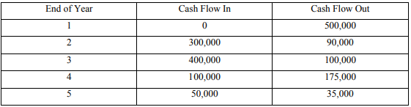
- What is the payback period for this project?
- What is the net cash flow at the end of five years? (Marks 04)
Question 3: Answer the given questions; (Marks 02)
- Draw the testing workflow.
- List down key areas for code of conduct of PMI has been written by practitioners to organize.
------------------

